War in the Pacific

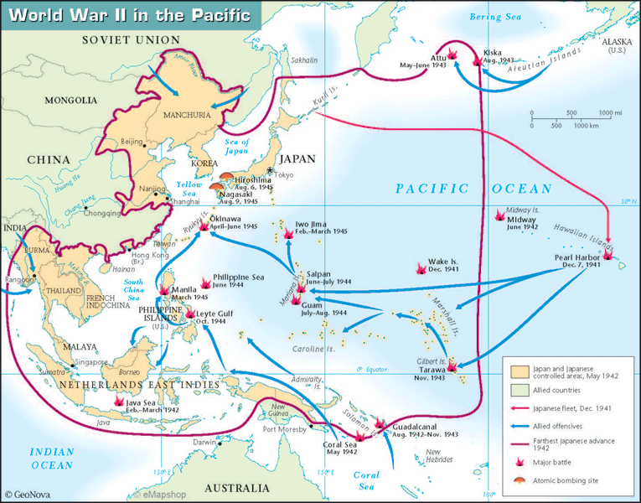

1. Name five countries that Japan had at least partial control of by 1942? _____________, ___________, ____________, _____________, & ______________
2. The Allied offences is colored in? ____________
3. When was the attack on Pearl Harbor? _______________
4. When was the Battle of Midway Island? ______________
5. Put these four battles in order Leyte Gulf, Iwo Jima, Guadalcanal, Okinawa _____________, ______________, ______________, & __________________
6. Name the two cities that the Atomic bomb was dropped?____________&____________
7. Attach a picture of a Kamikaze assault on a US Ship.
8. Attach a picture of the aftereffects of the Atomic Bombs dropped over Japan.